

**Advice note to DAFM,**

**4 of 2016**

**June 20th**

**(Fisheries Ecosystems Advisory Services,** [**oliver.tully@marine.ie**](mailto:oliver.tully@marine.ie)**)**

**A Minimum Landing Size for Velvet Crab**

# The fishery

Velvet crabs (*Necora puber*) are predominantly a by-catch in the lobster fishery. This by-catch is more significant in some areas than others and targeted fisheries for velvets also occur on the east coast in particular. Landings in 2015 were higher than any year since 2004. This may reflect a general increase in effort on lobster or an increasing tendency to retain and land velvet crab by-catch caught in the lobster fishery (Figure 1).

The main ports where velvets are landed include Kilmore Quay and Helvick in the south east, Schull, Skibereen and Castletownbere in west Cork and Howth and Skerries in Dublin (Figure 2).

The value of the landings in 2015 was €419K and this was distributed across 221 vessels under 10m in length. The species therefore contributes some income to a significant number of small vessels. Over 80% of velvets are landed by vessels under 10m in length.

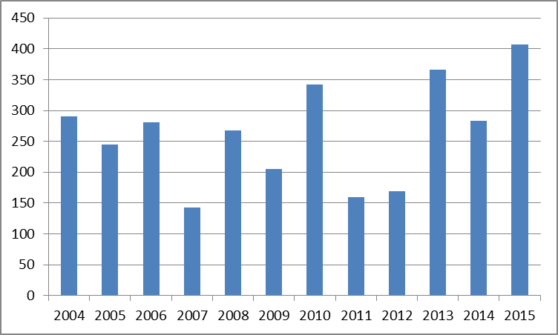

Figure 1. Annual landings (tonnes) of velvet crab into Irish ports 2004-2015

Table 1. Main ports of landing of velvet crab in 2015.

The number of consignments/sale events is indicated

|  |  |
| --- | --- |
| Port | Number of consignments |
| Kilmore Quay | 739 |
| Schull | 323 |
| Howth | 280 |
| Skibbereen | 175 |
| Helvick | 165 |
| Castletownbere | 159 |
| Skerries | 135 |
| Ballycotton | 90 |
| Dunmore East | 83 |
| Fethard/Slade | 70 |
| Bantry | 59 |
| Rosslare | 55 |
| Galway | 52 |

# Stock status and risk of overfishing

The status of Velvet crab stocks is not known. However, it is reasonable to expect that they are under increasing pressure in some locations as effort in the lobster fishery increases. Fishermen have reported that the fishery in Galway Bay has collapsed or at least has very significantly declined in recent years. There are no reports of such dramatic declines elsewhere although this does not mean that declines have not occurred.

The risk of recruitment or growth overfishing of velvet crabs is not considered to be high for the following reasons

1. The size distribution of crabs in the landings generally ranges from 45-100mm with a modal size of 70-80mm. This is partly due to gear selectivity (smaller crabs will not be retained in lobster pots given the mesh size and bar spacing in the pots) and also grading on board where crabs below the perceived market size are discarded
2. Discard survival is likely to be high
3. The size of crabs in the landings is generally higher than the size at maturity (Figure 2). 50% of female crabs are mature at 49mm (Figure 3) whereas the average size in the catch is 70-80mm.
4. Mature crabs may produce more than 1 brood per year and therefore multiple broods are likely to be produced by each female crab before it becomes vulnerable to fishing. Spawning escapement therefore seems to be well protected by the current combination of grading practice and gear selectivity.

At least some stocks also face other pressures and sources of mortality. A recent study in Galway Bay found a high prevalence of potentially lethal infections of *Paramartelia* and lower prevalence of *Haematodinium* (bitter crab disease) and a *Microsporidean* sp. These infections are likely to be a significant source of mortality of crabs in Galway Bay. It is intended to extend this study to other areas.

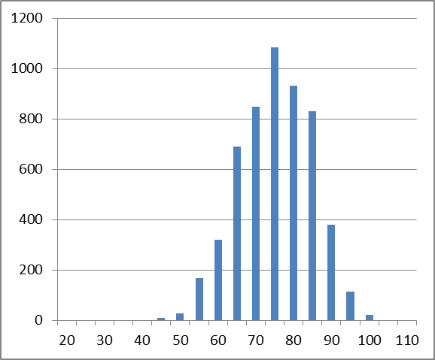

Figure 2. Size distribution of velvet crabs in the catch (Galway Bay)





Figure 3. Size at maturity of velvet crabs. Top: female; Bottom: male.

# The need for a Minimum Landing Size (MLS)

* The velvet crab fishery is currently completely unregulated. This is exceptional in Irish shellfish fisheries as other species have at least a legal minimum landing size to protect stocks from growth overfishing and ideally recruitment overfishing. The minimum landing size in the UK is 65mm.
* Grading practice may not be as described above universally and smaller crabs may be landed thus reducing spawning potential. There have been anecdotal reports in the past of landing of very small crabs presumably using specialised velvet crab gears with smaller mesh and bar spacing.
* A minimum landing size would seek to guarantee that smaller crabs would not be landed. This would at least fix the spawning escapement per recruit at a minimum level defined as the number of spawning events that would occur prior to the crab recruiting to the fishery (the remaining egg production of a crab would then be determine by the annual fishing mortality rate or probability of being removed from the stock).
* A legal minimum size as opposed to a market driven minimum size would require that fishermen strictly complied with the legal measure. A gauge would need to be distributed to fishermen. For vessels targeting velvets and therefore landing larger volumes this would increase grading (sorting) time on board. This could be partly offset by using escape panels on velvet crab gear. From previous Irish studies a circular panel of 47mm diameter seems to be the best option of selecting out crabs below 65mm.

# Conclusion

* Velvet crab stocks are likely to be exposed to increased fishing pressures in areas where lobster effort is increasing and also in areas where targeted fishing for velvet crab occurs
* Good grading and handling of crabs on board to exclude small crabs and to optimise discard survival is necessary to protect the stock against overfishing where fishing effort is increasing
* Some stocks (Galway Bay) are exposed to additional natural mortality caused by parasites and diseases. It would be prudent to reduce fishing mortality in such stocks.
* The need to introduce a minimum landing size for velvet crab depends mainly on how effective current grading practices, based on market demand, are in removing small crab (<65mm) from the landings. The efficacy of such a voluntary or market driven measure is not well known as sampling data for velvet landings is poor i.e. we don’t know what proportion of crab in the landings is below 65mm. This can be rectified relatively quickly by sampling at different landing points or at buyers.

END